TASK 3:

Create a public repo HAZESOFT-T3 in your github account.

Create a script called backup.sh that takes a single argument: the path of a directory to back up. The script should create a compressed tar archive of the directory, save it with a timestamped name in a specified backup directory, and print a message indicating whether the backup was successful or not.

………………………………………………………………………………………………………………

I created the repo named as “HAZESOFT-T3” in github account.

Then i created the file “bacup.sh” inside the hazesoft/shellscript using following command

mkdir hazesoft

cd hazesoft

mkdir shellscript

touch backup.sh

Then i write the following command inside the backup.sh file

#!/bin/bash

# check if directory path is provided as an argument

if [ "$#" -ne 1 ]; then

echo "Usage:$0 ./shellscript"

exit 1

fi

# Input directory to backup

source_directory="$1"

# Backup directory

backup_directory="backup"

mkdir -p "$backup_directory"

#Timestamp for the backupd file

timestamp=$(date "+%Y%m%d_%H%M%S")

backup_filename="$backup_directory/$timestamp.tar.gz"

#Create compressed tar archive

tar czf "$backup_filename" "$source_directory"

#check id the backup was successful

if [ $? -eq 0 ]; then

echo "backup successed ..archived saved as :$backup_filename"

else

echo "error :backup failed"

fi

Then i saved it.

Then i run the command for backuping the file.

bash backup.sh ../shellscript

Then backup is done..

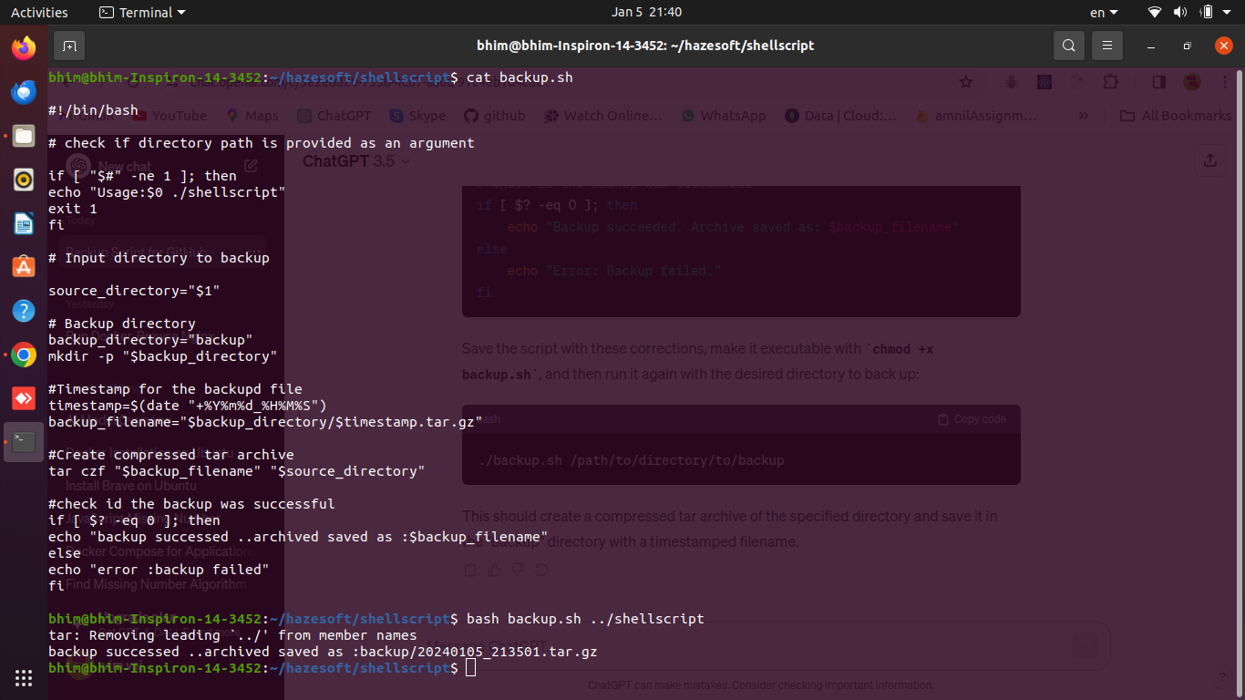

The executed command shows the above result..

We can see the backup files in the backup directory.  
